**A**

**MINI PROJECT REPORT**

**ON**

**“Online Job Portal”**

**BY**

**Mr.Walunj Pranav Namdev**

**SAVITRIBAI PHULE PUNE UNIVERSITY**

**MASTERS IN COMPUTER APPLICATION**



**Akole Taluka Education Society’s**

**TECHNICAL CAMPUS AKOLE**

**2020-2021**

CERTIFICATE

This is to certify that, the **Mini Project Report** entitled **“Online Job Portal”**,which is being submitted herewith for the award of the Degree of **Master In Computer Application** semester I under the faculty **Commerce and Management** of **Savitribai Phule Pune University, Pune** is the result of original research work completed by **Mr.Walunj Pranav Namdev,** under my supervision and guidance. To the best of my knowledge and belief the work embodied in this Mini Project Report has not submitted earlier for the award of any Degree, Diploma, Associateship, Fellowship or similar title in this or any other University or any other Examining Body.

I give an undertaking that the material included in the Mini Project Report from other sources are duly acknowledged.

**Project Guide Name**

**Prof.Kiran A.Shejul**

I have verified that, the research student has incorporated all the changes as suggested by Pre-submission Presentation Committee, if any.

**Place :Akole Dr. Prashant Radhakrishna Tambe**

**Date : ___/___/2021 Director**

DECLARATION

I, hereby declare that,the research work presented in the **Mini Project Report** entitled**“Online Job Portal”**submitted for the award of the Degree of **Master In Computer Application** semester I under the faculty **Commerce and Management** of **Savitribai Phule Pune University, Pune** is an outcome of my own efforts and a genuine research work done under the guidance of **Prof.kiran A.Shejul**. I also declare that, this mini–Project Report or any part therein has not been previously submitted by me for the award of any Degree, Diploma, Associateship, Fellowship or Titles in this or any other University or any other Institution of Higher Learning.

I, further declare that the material obtained from other sources has been duly acknowledged.

**Place :Akole**

**Date : __ / __ / 2021 Name of student:Walunj Pranav Namdev**

ACKNOWLEDGEMENT

*This Mini project report is a fruitful outcome of experiences, challenges, and relationships involving many great people to whom I am more indebted than I can possibly acknowledge. Some of them, however, deserve special thanks. I take this opportunity with much pleasure to thank all, who directly and indirectly contributed, helped me for this mini-Project.*

*I, take this opportunity to express my deep sense of gratitude and indebtedness to my research guide* ***Prof.Kiran A.Shejul***  *for his keen interest, dynamic guidance and constant encouragement. I, express deep sense of gratitude* ***to Dr. Prashant Radhakrishna*** ***Tambe, Director - ATES’s Technical Campus, Akole*** *for his continuous encouragement and support to complete this mini–Project Report.*

*I, owe sincere thanks to* ***Mr.Prof.Kiran A.Shejul, Mr.prof.Vaibhav.B.Dongare,***

***Mr. Prof.Sanket.C.Dhawale*** ***,****and* ***Mr. Prof.Amol Nawale*** *for their stimulating support to complete this Project Report.*

**Place :Akole**

**Date : __ / __ /2021 Name of student: Walunj Namdev Walunj**

**INDEX**

|  |  |  |
| --- | --- | --- |
| **Sr. no** | **Title** | **Page no** |
| **1.** | **Introduction** |  |
| i) | **Introduction to System** | 7. |
| ii) | **Scope of System** | 8. |
| iii) | **Proposed of System** | 9. |
| **2.** | **System Analysis** | 10. |
| i) | **Fact Finding Techniques** | 10. |
| ii) | **Feasibility Study** | 10. |
| iii) | **Hardware & Software Requirement** | 12. |
| **3.** | **System Design** |  |
| i) | **Entity Relationship Diagram** | 13. |
| ii) | **Context Level Diagram** | 14. |
| **4.** | **Form Design(with input values)** | 15. |
| **5.** | **Advantages & Disadvantages** | 21. |
| **6.** | **Feature Enhancement** | 22. |
| **7.** | **Bibliography** | 23. |

# Introduction

This project deals with the requirements of a online job portal which is supposed to provide a online facilities to find jobs. The job portal is required to find different types of jobs in our website in free of cost .The **“JOB PORTAL”** is a web application written in Windows operating systems which is focused in finding jobs . This project is a menu driven project and to make it user friendly it is implemented in the form of GUI (Graphical User Interface).There are basically four modules in this project:

Administrator

Job Seeker

Job Provider

Job Search

System Users

The first and the foremost module is the LOGIN module .In this frame the user is required to fill user name and password.

The next module is the ADMIN LOGIN. Here it provides various options like job post, job filter ,help, feedback etc.

The third module is JOBS FILTER PAGE. Here the user enter the details of which kind of job he/she wants to prefer. The user will enter the category or type of jobs available in different

.

**SCOPE OF SYSTEM**

The researcher is concerned with an Online Job Portal, Scopes for the system are as follows. -

1. Maintain Job Seeker and Employer records

2. Maintain uploaded Resumes

3. Provide Customized Job Postings

4. Maintain Job Posting details and generate various reports.

**PROPOSED SYSTEM**

**Objective**

The proposed system is very useful for the clint side of JOB PORTAL. This avoids the overheads of maintaining data manually. This can minimize the working stress and can keep essential documents related to registration and complaints as a softcopy. The registration form details like Name, email, phone number, gender, date of birth, userid, password can be easily managed. The whole data is saved in a database which is a secure way to keep the records.

**Functions*:***

1. USER LOGIN PAGE: in this the user can enter the username and password and can access further pages or they can create the new account to search for jobs.
2. ADMIN LOGIN PAGE: it provides with various options like job post , job filter ,help, feedback etc.
3. JOB FILTER PAGE: in this the user can search for various types of jobs they prefer.
4. JOB POSTS PAGE: in this they can give their details and search for jobs.

#### ADVANTAGES OF PROPOSED SYSTEM

* + - User friendly interface
    - Fast access to database
    - Less error
    - More Storage Capacity
    - Search facility
    - Look and Feel Environment
    - Quick transaction

# System Analysis

#### DEFINITION:

System Analysis is a detailed study of the various operations performed by a system and their relationships within and outside of the system. It is the process of analyzing the system that has to be automated or the existing system. In this phase the whole system is analyzed and the requirements of the system are specified. The requirements include both the software requirements and hardware requirements. Next the Feasibility study for the system is done. This includes both the Technical feasibility and Economic feasibility (cost and benefit analysis). In Incremental Development model, the analysis phase mainly concentrates on the main requirements of the system that are fulfilled in the design of the core product.

During analysis, data collected on the various files, decision points and transactions is handled by the present system. The commonly used tools in the system are Data Flow Diagram, interviews, etc. Training, experience and common sense are required for collection of relevant information needed to develop the system. The success of the system depends largely on how clearly the problem is defined, thoroughly investigated and properly carried out through the choice of solution. A good analysis model should provide not only the mechanisms of problem understanding but also the frame work of the solution. Thus it should be studied thoroughly by collecting data about the system. Then the proposed system should be analyzed thoroughly in accordance with the needs. System analysis can be categorized into five parts.

* + - System planning and initial investigation
    - Information Gathering
    - Applying analysis tools for structured analysis
    - Feasibility study
* Cost/ Benefit analysis

#### REVIEW OF EXISTING SYSTEM

Registration Forms

All information regarding registration First name, Middle name, Last name ,

e-mail, phone number etc, details filled by user and then are stored in the records..

Separate Databases were kept at separate sites.

Usage of database for storing each and every record was very high.

Maintenance of record takes very much time. Because everything was manual so maintenance was difficult.

Study Material.

The study material is all of the java programming books available in the website

All the details were not available.

Chat and Query

To maintain an admin to chat and query section about users.

* + The details are filled in database in the user records.

❖ Help

➢ The help section provides all helps related to this website.

#### PROBLEM WITH THE EXISTING SYSTEM

Communication involved a lots of database work. The system was not a computer based

application as a result communication among the 5 functions involved a lot of databse work .i.e. in case the user forgot the user id while filing the complaint then there is no response suddenly in the website about on admin in the help desk.

* + - Being completely manual, there is always a possibility of manual mistakes in proceeding

with the system.

* + - Large amount of data was stored but it will hanged system.
    - There was no web server available in website in domain name of the website are not available to show only a local host.

#### FEASIBILITY ANALYSIS

Feasibility is the study of impact, which happens in the organization by the development of a system. The impact can be either positive or negative. When the positives nominate the negatives, then the system is considered feasible. The feasibility of the system can be judged according to its workability impact on the organization, ability to meet user needs and the effective use of resources. One should keep in mind the need of the user and how does a candidate system meet it. Here the feasibility study can be performed in three ways such as technical feasibility, economical feasibility and operational feasibility

#### Technical Feasibility:

The assessment of technical feasibility is based on an outline design of system requirements in terms of Input, Processes, Output, Fields, Programs, and Procedures. This can be quantified in terms of volumes of data, trends, frequency of updating, etc. in order to estimate whether the new system will perform adequately or not. Technological feasibility is carried out to determine whether the company has the capability, in terms of software, hardware, personnel and expertise, to handle the completion of the project.

#### Economical Feasibility

Economic feasibility is a method for evaluating the effectiveness of a new system. The procedure is to determine the benefits and savings that are expected from a candidate system and compare them with costs. If benefits outweigh costs, then the decision is made to design and implement the system. An entrepreneur must accurately weigh the cost versus benefits before taking an action.

This system is economically feasible also as the cost of making the project is very low as installation of Java Development Kit and MYSQL is free and can be installed on any system. Cost in developing the software is very low, as compared to the money spent on the existing system. Also the money spent can be recovered only in just the duration of six months.

#### 2.6. 3Operational Feasibility:

The management’s requirement is also taken into consideration when the system is designed. Operational feasibility of **JOB PORTAL** is satisfied as the running of this system satisfies the client and the management is also satisfied by the economic and technical feasibility.

# Requirement Analysis

The Requirement Management deals with analyzing, developing, maintaining, documenting, and verifying customer requirements. The customer’s requirements need to be tracked throughout the project life cycle to ensure that the final product meets all the requirements. Requirement Outputs, such as Software Requirement Specifications or any other document may be produced.

The analyst (or a team) determines the requirements of the customer or end user. A variety of techniques may be used to study the requirements such as, interviews, evaluation of similar products or projects, discussions etc.

The requirements are analyzed to ensure that they are feasible and appropriate to implement in software, clearly stated, consistent with each other, testable, and complete. To analyze the requirements various techniques may be used e.g. Data Flow Diagrams, functional decomposition, object-oriented decomposition, simulations, modeling, prototyping, etc. Issues affecting the requirement analysis are identified and resolved. Each of the outputs will be peer- reviewed as per review Procedure and approved at one or more points as decided by the Project Manager at the time of Project Planning.

#### SOFTWARE REQUIREMENT SPECIFICATION :

In the very first phase for our application we try to capture all the requirement specifications. Software Requirement Specification presents all the requirements along with the particular constraints and it also includes the team structure etc.

#### Purpose Of This Section:

This section describes the requirements for the **JOB PORTAL ,** review the existing system along with the users.

During the study, the particular requirements of the client are made the basis of the document. This is an endeavor to document that proposed **JOB PORTAL** as understood by System Analysts. This document would form the basis for Development team.

#### Functions Of The System:

**➢** Registration Of New Users

**➢** Searching for jobs (job filter)

**➢** Jobs post

**➢** help

**➢** feedback

#### HARDWARE AND SOFTWARE REQUIREMENTS:

* + 1. **Software Requirements:**
       - Front End – HTML CSS
       - Back End – Paython,MySql
       - Windows 10

#### Hardware Requirements:

* + - * Computer system with :
        + 1 GB RAM minimum
        + 40 GB Hard Disk minimum
        + Pentium4 or DUAL CORE 2.20GH Processor
        + Monitor
        + Keyboard
        + Mouse

# System Designing

System Designing involves the analysis, design, and configuration of the necessary hardware and software components to support your solution's architecture. The purpose of System Design is to create a online education which is supposed to provide a online facilities to learn education. At this point in the project lifecycle there should be a Functional Specification, written primarily in business terminology, containing a complete description of the operational needs of the various organizational entities that will use the new system. The challenge is to translate all of this information into Technical Specifications that accurately describe the design of the system, and that can be used as input to System Construction.

#### PROCESSES IN SYSTEM DESIGNING

This phase consists of the following processes:

* + - **Prepare for System Designing,** where the existing project repositories are expanded to

accommodate the design work products, the technical environment and tools needed to support System Design are established, and training needs of the team members involved

in System Design are addressed.

* + - **Define Technical Architecture**, where the foundation and structure of the system are

identified in terms of system hardware, system software, and supporting tools, and the

strategy is developed for distribution of the various system components across the architecture.

* + - **Define System Standards,** where common processes, techniques, tools, and conventions

that will be used throughout the project are identified in an attempt to maximize

efficiencies and introduce uniformity throughout the system.

* + - **Create Physical Database**, where the actual database to be used by the system is

defined, validated, and optimized to ensure the completeness, accuracy, and reliability of

the data.

* + - **Prototype System Components**, where various components of the solution may be

developed or demonstrated in an attempt to validate preliminary functionality, to better

illustrate and confirm the proposed solution, or to demonstrate “proof-of-concept.”

* + - **Produce Technical Specifications**, where the operational requirements of the system are

translated into a series of technical design specifications for all components of the system, setting the stage for System Construction.

#### TYPES OF SYSTEM DESIGN

* + 1. **Input Design**

Input design is the process of converting user-oriented input to a computer based format. Input design is a part of overall system design, which requires very careful attention. Often the collection of input data is the most expensive part of the system. The main objectives of the input design are:

* + - 1. Produce cost effective method of input
      2. Achieve highest possible level of accuracy
      3. Ensure that the input is acceptable to and understood by the staff.

#### Input Data

The goal of designing input data is to make entry easy, logical and free from errors as possible. The entering data entry operators need to know the allocated space for each field, field sequence and which must match with that in the source document. The format in which the data fields are entered should be given in the input form .

Here data is input from the user in the end then it makes use of processor that accepts commands and data from the operator through a keyboard. The input required is analyzed by the processor. It is then accepted or rejected. Input stages include the following processes

* + - * + Data Recording
        + Data Transcription
        + Data Conversion
        + Data Verification
        + Data Control
        + Data Transmission

One of the aims of the system analyst must be to select data capture method and devices, which reduce the number of stages so as to reduce both the changes of errors and the cost .Input types, can be characterized as:

* + - * + External
        + Internal
        + Operational
        + Computerized

#### Output design

Outputs from computer systems are required primarily to communicate the results of processing to users. They are also used to provide a permanent copy of this result for later consultation. Computer output is the most important and direct source of information to the users. Designing computer output should proceed in an organized well throughout the manner. The right output must be available for the people who find the system easy to use. The outputs have been defined during the logical design stage. If not, they should defined at the beginning of the output designing terms of types of output connect, format, response etc.

Various types of outputs are

* External outputs
* Internal outputs
* Operational outputs
* Interactive outputs

Turn around

**Daigrams**

**1.ERD**

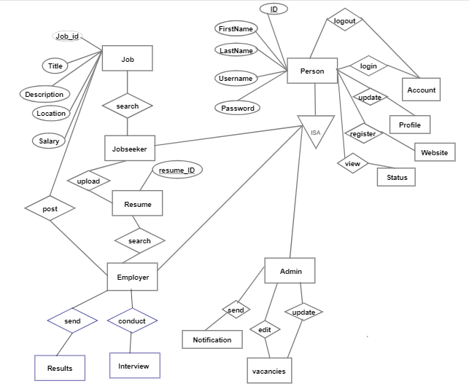

**2.DFD**

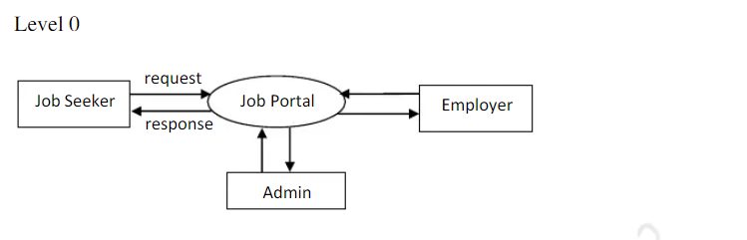

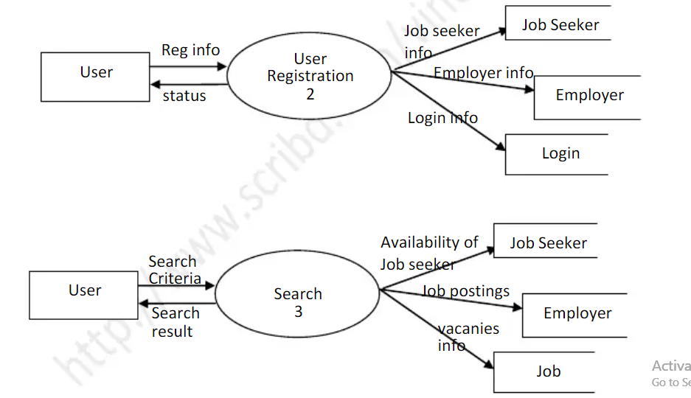

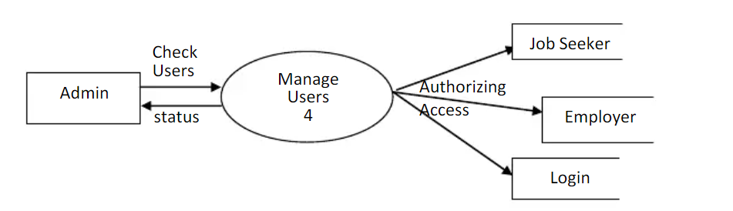

**3.Usecase**

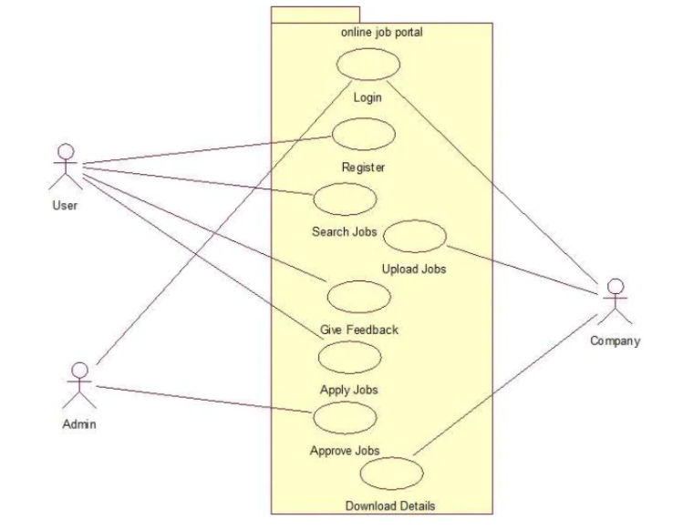

**4.Sequence**

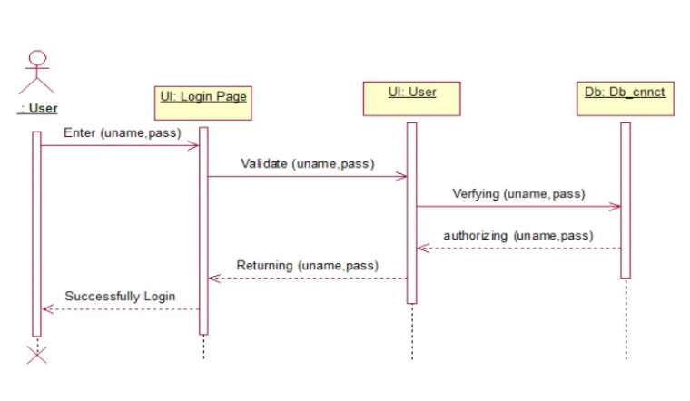

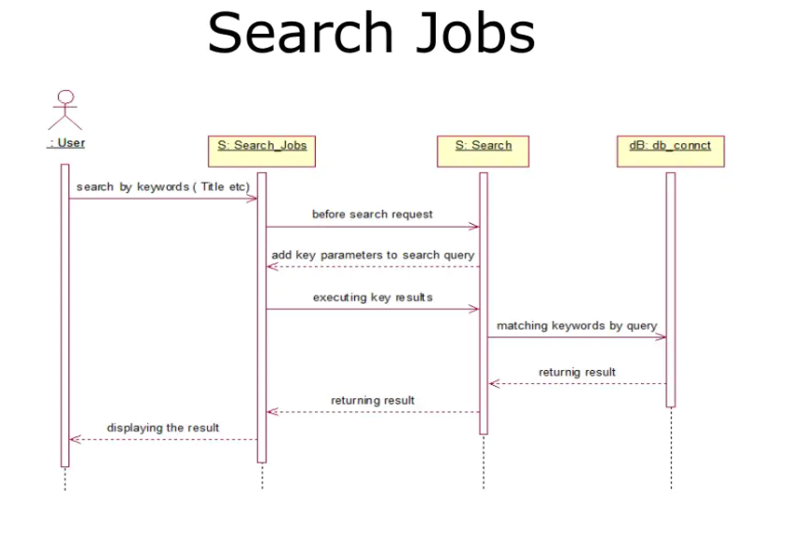

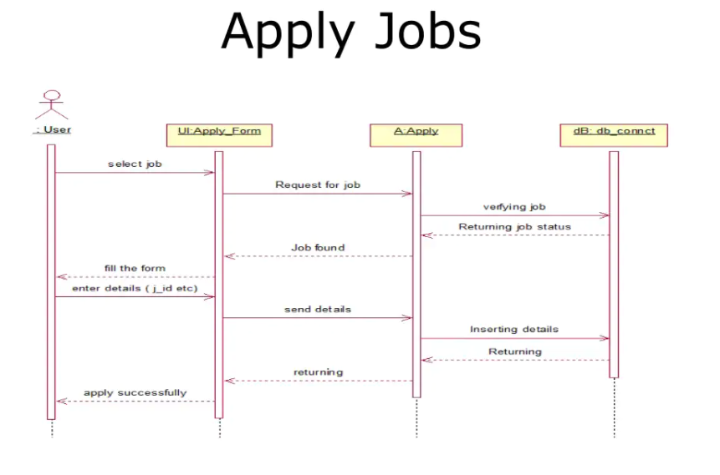

**Database design**

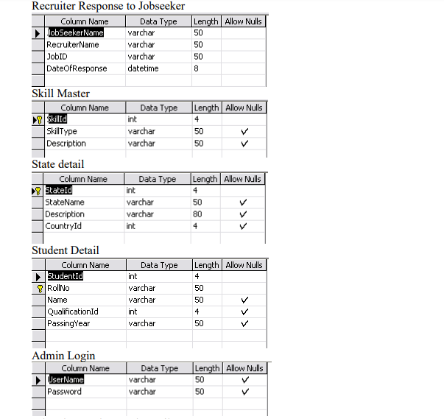

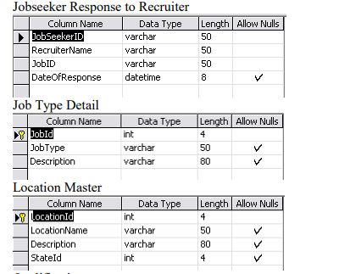

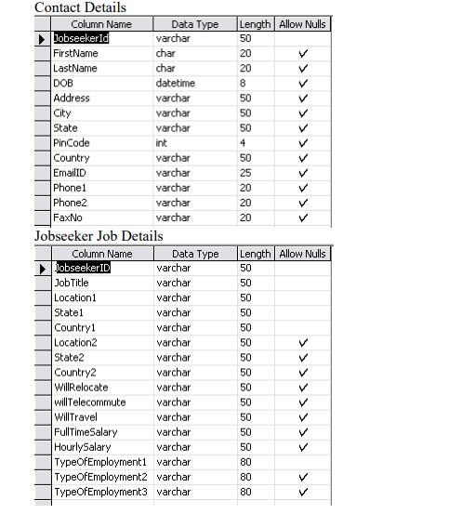

**Output Forms**

**1.Login Form**

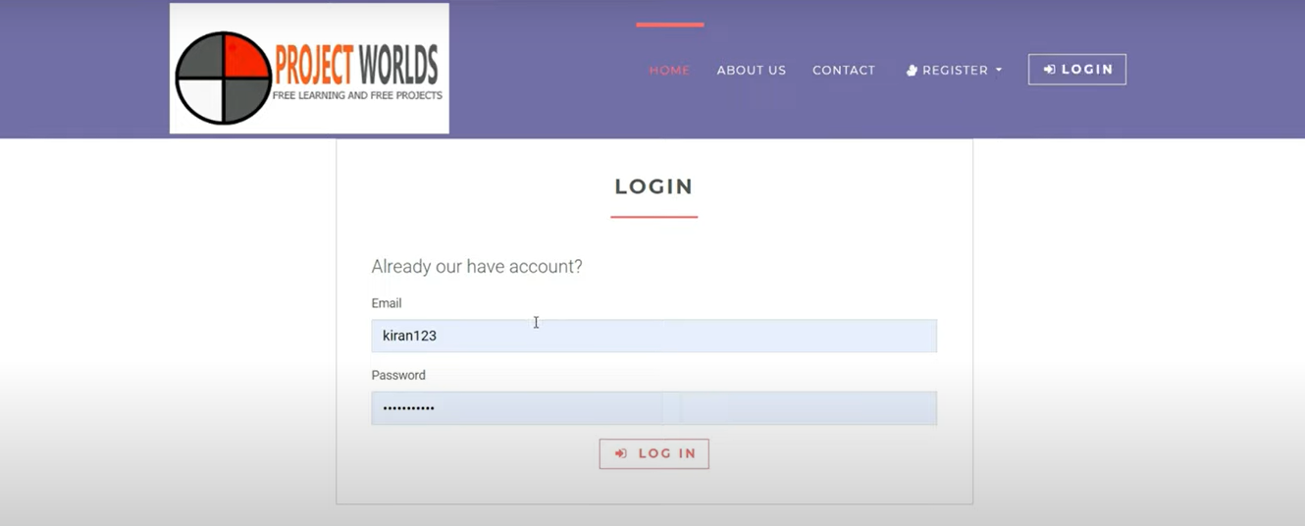

# 2.Search Page



# 3.Jobs Page

# 

# 4.Job-Discribtion

# 

**Conclusion**

The project titled “JOB PORTAL” is only a humble venture to fulfill the requirements of a client in finding jobs. Several user friendly coding has been developed. This package shall prove to be a powerful package in satisfying all the requirements of the user.

The objective of making a blueprint is to provide a framework that enables the programmer to make reasonable estimates made within a limited time frame at the beginning of the software project

# Future Scope

This project can be developed into full-fledged software and can be extended according to the specifications of the end user. Various attributes in each frame can be added according to the needs of the client. To ensure its wide range of use the Student system used in the project can be authenticated by the authorities so that it becomes a real world application. Various other functions can be added wherein the project not only acts as an inventory project but its usage is defined for some more real world applications.

# Bibliography

* + - 1. **Python Crash Course: A Hands-On, Project-Based Introduction to Programming (2nd Edition).**
      2. **Head-First Python: A Brain-Friendly Guide (2nd Edition)**

**3. Learn Python the Hard Way: 3rd Edition**